NAME: PENIEL AMA KRAMPAH
ID NUMBER: 10976845
ASTA 607: COMPUTATIONAL STATISTICS I EXAMINATIONS

QUESTION 1:
- Description of dataset:
The data set contains morphological measurements on 200 crabs of the species Leptograpsus variegatus. The crabs were collected at Fremantle, W. Australia, and they were classified into two colour forms (orange and blue). The data set is a dataframe that consists of 200 rows and 8 columns, describing 5 morphological measurements on 50 crabs each of two colour forms and both sexes of the species.
The columns are:
- sp: Species - "B" or "O" for blue or orange.
- Sex: As it says.
- Index: Index 1:50 within each of the four groups.
- FL: Lobe size (mm).
- RW: Rear Width (mm).
- CL: Carapace Length (mm).
- CW: Carapace Width (mm).
- BD: Body Depth (mm).

- Loading the Data Set and displaying its structure:
R Code:
#Loading dataset and structure
data(crabs)
head(crabs)
str(crabs)

Results
sp sex index FL RW CL CW BD
1 B M 1 8.1 6.7 16.1 19.0 7.0
2 B M 2 8.8 7.7 18.1 20.8 7.4
3 B M 3 9.2 7.8 19.0 22.4 7.7
4 B M 4 9.6 7.9 20.1 23.1 8.2
5 B M 5 9.8 8.0 20.3 23.0 8.2
6 B M 6 10.8 9.0 23.0 26.5 9.8

'data.frame': 200 obs. of 8 variables:
$ sp : Factor w/ 2 levels "B","O": 1 1 1 1 1 1 1 1 1 1 ...
$ sex : Factor w/ 2 levels "F","M": 2 2 2 2 2 2 2 2 2 2 ...
$ index: int 1 2 3 4 5 6 7 8 9 10 ...
$ FL : num 8.1 8.8 9.2 9.6 9.8 10.8 11.1 11.6 11.8 11.8 ...
$ RW : num 6.7 7.7 7.8 7.9 8 9 9.9 9.1 9.6 10.5 ...
$ CL : num 16.1 18.1 19 20.1 20.3 23 23.8 24.5 24.2 25.2 ...
$ CW : num 19 20.8 22.4 23.1 23 26.5 27.1 28.4 27.8 29.3 ...
$ BD : num 7 7.4 7.7 8.2 8.2 9.8 9.8 10.4 9.7 10.3 ...
>

Table 1

- FREQUENCY TABLES FOR SPECIES AND SEX
R Code
# Frequency table for species and sex
(freqtab_sp_sx <- table(crabs$sp, crabs$sex))

Results
FREQUENCY TABLE FOR SPECIES AND SEX
F M
B 50 50
O 50 50

Table 2

- R Code:
par(mar=c(4,4,1,1))
barplot(freqtab_sp_sx, main = "Group Composition of Crab Species",
ylab = "Frequency", col = c("lightblue", "orange"), beside = TRUE,
legend = c("Blue Crab", "Orange Crab"), args.legend = list(x = "topright"),
ylim = c(0,60))

Results:

BAR CHART SUMMARISING THE GROUP COMPOSITION OF THE DATA SET
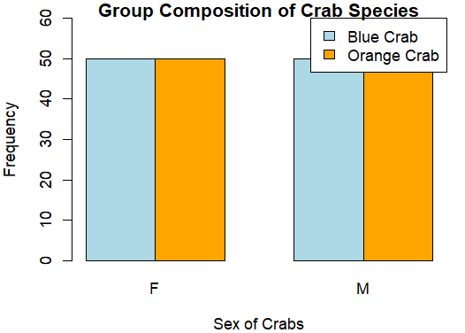
Figure 1

- The data is balanced across the four groups. Each group has the same composition of crabs, that is 50 crabs for each sex and 50 crabs for each crab species (Blue or Orange).

QUESTION 2:
- R Code:
par(mfrow=c(1,2), mar=c(4,4,1,1))
boxplot(BD ~ sp, data = crabs, main = "Boxplot of Body Depth by Species",
xlab = "Crab Species", ylab = "Body Depth", col = c("lightblue", "orange"))
boxplot(BD ~ sex, data = crabs, main = "Boxplot of Body Depth by Sex",
xlab = "Crab Sex", ylab = "Body Depth", col = c("green", "yellow"))

Results:

SIDE-BY-SIDE BOXPLOT OF BODY DEPTH (BD) FOR THE FOUR GROUPS DEFINED BY SPECIES AND SEX

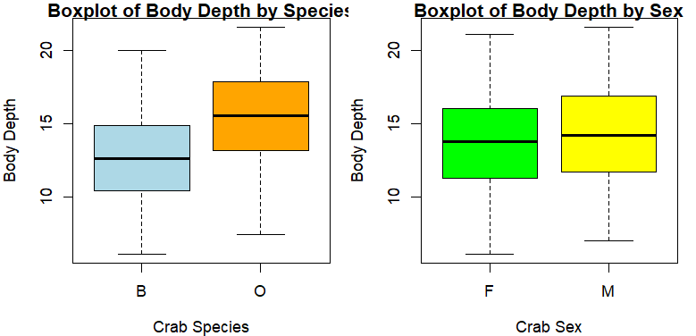
Figure 2

- The boxplot of body depth by species shows that the orange crabs tend to have a higher median body depth compared to the blue crabs. The Male crabs have a slightly higher body depth than that of the female crabs. The variability of all four boxplots are moderate and hence there is a moderate variability for all groups. There are no observed outliers.

QUESTION 3:
- R Code:
par(mfrow=c(1,2), mar=c(4,4,1,1))
# Histogram for Blue species
hist(crabs$CL[crabs$sp=="B"], main = "Blue species",
xlab = "Carapace Length (mm)",
col = "lightblue",
border = "black",
ylim = c(0,30))
# Histogram for Orange species
hist(crabs$CL[crabs$sp=="O"], main = "Orange species",
xlab = "Carapace Length (mm)",
col = "orange",
border = "black",
ylim = c(0,30))

Results:
SIDE-BY-SIDE HISTOGRAMS OF CARAPACE LENGTH FOR EACH SPECIES (BLUE AND ORANGE)
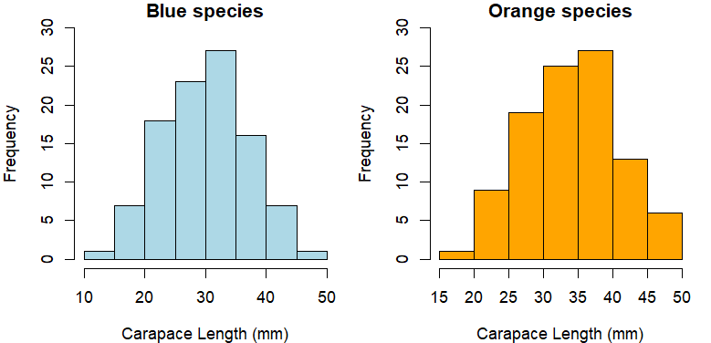
Figure 3

- COMMENT ON THE HISTOGRAM FOR CARAPACE LENGTH FOR BLUE SPECIES:
The histogram of carapace length for the blue species shows that the distribution is approximately normal with a very slight right skew. The majority of blue crabs have a carapace length between 20 and 40 mm, with fewer blue crabs having lengths outside this range. There are no significant outliers visible in the histogram. The distribution is unimodal.

COMMENT ON THE HISTOGRAM FOR CARAPACE LENGTH FOR ORANGE SPECIES:
The histogram of carapace length for the orange species also shows an approximately normal distribution, with a slight left skew. The majority of orange crabs have a carapace length between 25 and 40 mm, with fewer orange crabs having lengths outside this range. There are no significant outliers visible in the histogram. The distribution is unimodal.

QUESTION 4:
- Mean of each morphological measurement by sex and species:
R Code:
# Mean of each morphological measurement (FL,RW,CL,CW,BD) by species
mean_FL_sp <- tapply(crabs$FL, crabs$sp, mean)
mean_RW_sp <- tapply(crabs$RW, crabs$sp, mean)
mean_CL_sp <- tapply(crabs$CL, crabs$sp, mean)
mean_CW_sp <- tapply(crabs$CW, crabs$sp, mean)
mean_BD_sp <- tapply(crabs$BD, crabs$sp, mean)

means_morph_sp <- rbind(mean_FL_sp, mean_RW_sp, mean_CL_sp, mean_CW_sp, mean_BD_sp)
rownames(means_morph_sp) <- c("FL", "RW", "CL", "CW", "BD")
colnames(means_morph_sp) <- c("Blue", "Orange")

# Mean of each morphological measurement (FL,RW,CL,CW,BD) by sex
mean_FL_sex <- tapply(crabs$FL, crabs$sex, mean)
mean_RW_sex <- tapply(crabs$RW, crabs$sex, mean)
mean_CL_sex <- tapply(crabs$CL, crabs$sex, mean)
mean_CW_sex <- tapply(crabs$CW, crabs$sex, mean)
mean_BD_sex <- tapply(crabs$BD, crabs$sex, mean)

means_morph_sex <- rbind(mean_FL_sex, mean_RW_sex, mean_CL_sex, mean_CW_sex, mean_BD_sex)
rownames(means_morph_sex) <- c("FL", "RW", "CL", "CW", "BD")
colnames(means_morph_sex) <- c("Female", "Male")

print(means_morph_sp)
print(means_morph_sex)

Results:
Blue Orange
FL 14.056 17.110
RW 11.928 13.549
CL 30.058 34.153
CW 34.717 38.112
BD 12.583 15.478
> print(means_morph_sex)
Female Male
FL 15.432 15.734
RW 13.487 11.990
CL 31.360 32.851
CW 35.830 36.999
BD 13.724 14.337

- Grouped Bar chart displaying means:
R Code:
par(mfrow=c(1,2))
barplot(means_morph_sp, beside = T, ylim = c(0,40),
main = "Species")
barplot(means_morph_sex, beside = T, ylim = c(0,40),
main= "Sex")

Results:
GROUPED BAR CHART DISPLAYING MEANS OF EACH MORPHOLOGICAL MEASUREMENT BY SPECIES AND SEX
(in order of appearance of bars: "FL", "RW", "CL", "CW", "BD")
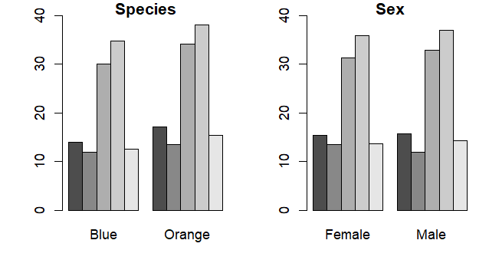

- From the “Species” above, CW (Carapace Width) shows the greatest species difference as compared to the other measurements. And also from the “Sex” graph, the CW (Carapace Width) also shows the greatest species difference as compared to the other measurements.

QUESTION 5:
- R Code:

pairs(crabs[, c("FL", "RW", "CL", "CW", "BD")],
main = "Scatter Plot Matrix of Morphological Measurements")

Results:
SCATTERPLOT MATRIX (PAIRS PLOT) OF THE FIVE MEASUREMENTS:

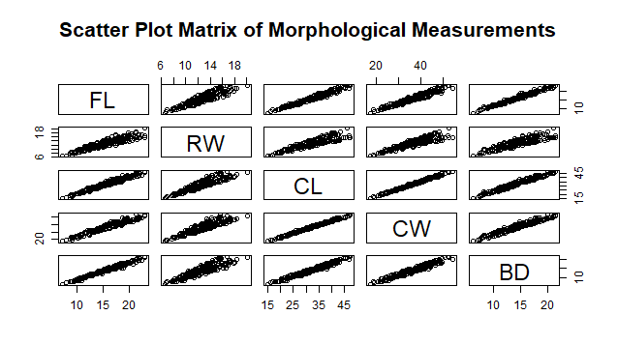
Figure 4

- The scatter plot matrix exhibits that there are positive correlations between the 5 morphological measurements. It can be seen that there is a strong positive correlation/relationship between carapace length (CL) and carapace width (CW), as well as between frontal lobe length (FL) and carapace length (CL). Overall, the scatter plot matrix indicates that the morphological measurements are positively correlated with each other.

QUESTION 6:

STATISTICAL REPORT

- INTRODUCTION
This comprehensive statistical report is to address the five questions answered above using the crabs dataset from the MASS package in RStudio. These questions address descriptive statistics/analysis which were performed on the crabs dataset and will be interpreted in this report.

- ANALYSIS
2.1: DATA STRUCTURE AND GROUP COMPOSITION
The data set which was used in this analysis, is the crabs data set which was obtained from the MASS package in RStudio. The data set contains morphological measurements on 200 crabs of the species Leptograpsus variegatus. The crabs were collected at Fremantle, W. Australia, and they were classified into two color forms (orange and blue). The data set is a data frame that consists of 200 rows and 8 columns, describing 5 morphological measurements on 50 crabs each of two colour forms and both sexes of the species.
The columns are:
- sp: Species - "B" or "O" for blue or orange.
- Sex: As it says.
- Index: Index 1:50 within each of the four groups.
- FL: Lobe size (mm).
- RW: Rear Width (mm).
- CL: Carapace Length (mm).
- CW: Carapace Width (mm).
- BD: Body Depth (mm).
The structure of the data set shows that it is a data frame with the five measurements being numeric, the index an integer and the species and sex are factors. The data is balanced across the four groups. Each group has the same composition of crabs, that is 50 crabs for each sex and 50 crabs for each crab species (Blue or Orange).

2.2: DISTRIBUTION OF BODY DEPTH

2.2: DISTRIBUTION OF BODY DEPTH

- CONCLUSION

